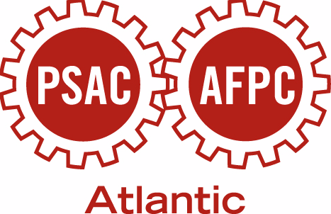
PSAC Atlantic School
May 23 – 27, 2012
St. Francis Xavier University
Antigonish, NS

APPLICANT INFORMATION

WHAT IS THE ATLANTIC SCHOOL?

Some have said:

‘Terrific learning’
‘An excellent event for networking’

Indeed, it is a learning event for active stewards and others who represent members in the workplace, the opportunity to gain knowledge and skills. You will network with other PSAC members from across the Atlantic region and return to your workplaces and locals energized.

SCHOOL SCHEDULE

Registration will be take place in the evening on Wednesday, May 23rd, from 5:00 pm to 9:00 pm or at 8:00 am on Thursday, May 24th. The School will start at 9:00 am on May 24th and end at noon on Sunday, May 27th.

LOCATION

The beautiful surroundings and modern facilities at the St. Francis Xavier University continue to be the right setting for our School in the Town of Antigonish. You may view the facilities by accessing www.sftx.ca. The address is St. Francis Xavier University, 1 West Street, Antigonish, NS. The telephone number is (902) 863-3300 and the fax number is (902) 867-5145.

Participants will be accommodated on campus unless someone has special requirements. All bedrooms are individual with hotel style accommodations (private bathroom, fridge, micro-wave oven, coffee maker).

SCENT FREE

All PSAC courses are scent free and participants are asked to use unscented products. Please refrain from using perfumes and colognes.

COSTS AND EXPENSES

There is a registration fee of $75 to help defray the costs of school mementos for participants. However, no undo hardship will be placed upon any member or local. There is no other cost to PSAC members.

Where possible, we are depending on local and component activists to negotiate employer-paid training time and transportation expenses. Replacement wages will be paid for those PSAC members who are unable to obtain training time from their employer and must apply for leave without pay.

TRANSPORTATION
The most economical means of transportation will be explored. Participants wishing to use their private vehicle will be eligible for a vehicle allowance of .30¢/km or the equivalent cost of a single seat on a van charter or vehicle rental. Arrangements will be made with each participant in advance of the School.

How To Apply

Complete the attached application form and forward to your nearest
PSAC Regional Office.
Apply early. Application deadline is March 9, 2012.
Selections will be based on the training needs of the union so please be sure to forward a completed application form with the necessary recommendations.

Young Worker

To encourage and support activism among our younger members, each of the five regions in the Atlantic will be offered one seat for an applicant who is 30 years of age or younger.

