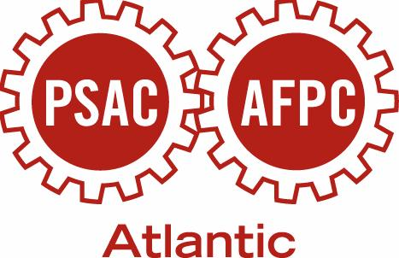

EDUCATION SCHEDULE
ST. JOHN’S REGION

Spring 2014

Date & Location | Course & Description | Application Deadline
April 12 – 13, 2014  PSAC Boardroom | Grievance Handling  This course provides new PSAC shop stewards with essential basics for grievance handling and effective stewarding. | April 4
May 31 – June 1, 2014  PSAC Boardroom  St. John’s | Convention Preparation Course& Interpreting the Collective Agreement  The purpose of this session is to assess participants’ knowledge and experience of convention process and provide a comfortable forum for introductions. Interpreting the Collective Agreement will enhance your understanding of what a collective agreement is and what is in it. | May 16
May 31 – June 1, 2014  TBA  Corner Brook | Convention Preparation Course & Interpreting the Collective Agreement  The purpose of this session is to  assess participants’ knowledge and experience of convention process and provide a comfortable forum for  introductions. Interpreting the Collective Agreement will enhance your understanding of what a collective agreement is and what is in it. | May 16
May 31 – June 1, 2014  TBA  Gander | Convention Preparation Course & Interpreting the Collective Agreement  The purpose of this session is to assess participants’ knowledge and experience of convention process and provide a comfortable forum for introductions. Interpreting the Collective Agreement will enhance your understanding of what a collective agreement is and what is in it. | May 16
May 31 – June 1, 2014  TBA  Goose Bay | Convention Preparation Course & Interpreting the Collective Agreement  The purpose of this session is to assess participants’ knowledge & experience of convention process & provide a comfortable forum for introductions. Interpreting the Collective Agreement will enhance your understanding of what a collective agreement is and what is in it. | May 16
UPCOMING CONFERENCES & EVENTS

PSAC Triennial Atlantic Regional Convention
Saint John Trade and Convention Centre
Saint John, NB
June 20 – June 22, 2014

