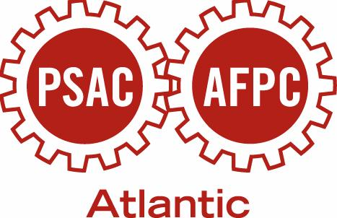

EDUCATION SCHEDULE
ST. JOHN’S REGION

Winter 2014

Date & Location | Course & Description | Application Deadline
Jan 17 - 19  PSAC Boardroom  St. John’s | Union Works for Women  The goal of the course is to build a better union, better workplaces and  a better society by encouraging and supporting active PSAC women in their struggle for fairness, equality and social justice. | Dec 19
Feb 22 & 23  PSAC Boardroom  St. John’s | Talking Union Business (TUB)  This course is the first introduction to the PSAC for most members and continues to be the foundation for more advanced union education. | Feb 7
Mar 29 & 30  PSAC Boardroom  St. John’s | Convention Preparation Course & Introduction to Duty to Accommodate  The purpose of this session is to assess participants’ knowledge and experience of convention process and provide a comfortable forum for introductions. The Introduction to Duty to Accommodate will provide an understanding of Duty to Accommodate in the workplace as it relates to human rights and membership representation. | Mar 7
Mar 29 & 30  TBA  Corner Brook | Convention Preparation Course & Introduction to Duty to Accommodate  The purpose of this session is to assess participants’ knowledge & experience of convention process & provide a comfortable forum for introductions. The Introduction to Duty to Accommodate will provide an understanding of Duty to Accommodate in the workplace as it relates to human rights and membership representation | Mar 7
Mar 29 & 30  TBA  Goose Bay | Convention Preparation Course & Introduction to Duty to Accommodate  The purpose of this session is to assess participants’ knowledge & experience of convention process & provide a comfortable forum for introductions. The Introduction to Duty to Accommodate will provide an understanding of Duty to Accommodate in the workplace as it relates to human rights and membership representation | Mar 7
Mar 29 & 30  TBA  Gander | Convention Preparation Course & Introduction to Duty to Accommodate  The purpose of this session is to assess participants’ knowledge & experience of convention process & provide a comfortable forum for introductions. The Introduction to Duty to Accommodate will provide an understanding of Duty to Accommodate in the workplace as it relates to human rights and membership representation | Mar 7
UPCOMING CONFERENCES & EVENTS

PSAC Triennial Atlantic Regional Convention
Saint John Trade and Convention Centre
Saint John, NB
June 20 – June 22, 2014

